Crash Reduction Analysis of Friction Enhancements in Georgia

Final Project: Special Research Problem CEE 4699

By

Matthew Liu

Jiashu Li

Ron Knezevich

Table of Contents

Abstract 3

Introduction 4

Background 5

Methodology 6

Spatial analysis: 6

Naïve bayes approach to develop CMFs: 6

Development of prediction models. 6

Use Empirical Bayes Method to develop high quality CMFs 6

Model CMFs as functions of the roadway environment 6

Results 6

Naïve Bayes CMFs 6

Developed SPFs: 7

Empirical Bayes CMFs Bayes CMFs 7

Influential factors 7

Discussion 7

Different materials 7

Discussion on COVID 7

Crash Types 7

Use of EB method 7

CMF model 7

Conclusion 8

# Abstract

# Introduction

Curve-related crashes represent approximately 25% of all roadway fatalities, and roughly 70% of these crashes are due to roadway departures (ref). To mitigate roadway and lane departure crashes, a common treatment utilized is high friction surface treatment or HFST. HFST is rough aggregates bonded to a roadway surface with an epoxy known as calcined bauxite. HFST is a proven safety counter measure (ref FHWA). It is usually implemented alongside other safety treatments such as signage, rumble strips, etc. HFST and other friction improvements have been implemented in hundreds of sites in Georgia (ref HFST report GA). To analyze the effectiveness of friction improvements, the long-term friction of sites is often assessed and the crash reduction that occurred is assessed. Crash modification factors are a quantifiable measure of the crash reduction of a safety treatment.

Georgia has implemented HFST and two other friction improvements. These friction improvements are called Light weight aggregate (LWA) and phonolite. Light weight aggregate is an alternative aggregate used as a resurfacing material, and phonolite is an alternative epoxy-based friction improvement. Phonolite has been implemented in Wyoming and is often referred to as Wyoming Bauxite (ref HFST report).

Crash modification factors have not been developed in Georgia to assess the effectiveness of HFST and other implemented friction improvements. It is critical to develop CMFs for state specific conditions because the roadway environment between states is not necessarily the same, and different states have different strategies for the implementation of HFST. Additionally, no published CMFs have been developed for LWA and phonolite.

The objective of this study is to analyze the effectiveness of HFST and other friction improvements in Georgia. The various friction improvements are to be compared. Additionally, the crash types that HFST reduces the most of are assessed. Furthermore, relevant roadway characteristics that lead to a higher reduction in HFST are analyzed. This study uses Empirical Bayes and Naïve Bayes methods to develop crash modification factors, and a methodology is proposed to assess relevant crash types reduced and critical roadway characteristics that influence the effectiveness of HFST.

# Background

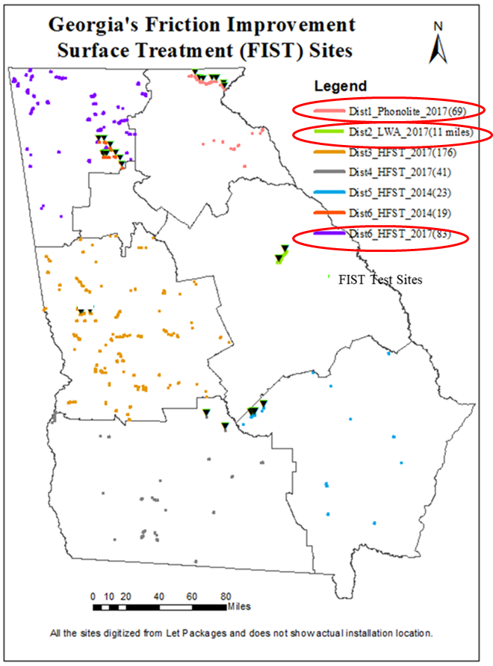

Crash modification factor, or CMF, is used to assess the efficacy of different HFSTs in terms of percentage of crash reduction after the treatment. CMFs are calculated using the formula: . Thus, a CMF of 0.75 means that the treatment brings 25% crash reduction to the studied locations, and a CMF more than one means this CMF is not helping to reduce the crash in a specific studied area.

The three FISTs, HFST, phonolite, and LWA, ~

////////////////////////////////////////////////////////////////////////////////////////////////////////////////////////////

Curve related crashes are one of the main causes of fatality in transportation in the US. Out of 37,206 total annual highway crash fatalities in the US, 8,767 are associated to horizontal curves (1). In response to this high number of fatalities, three types of FISTs are commonly used in the Georgia to mitigate this phenomenon. Georgia started implementing calcined bauxite HFST back in 2014, and later, in 2017, added Phonolite and LWA in district 1 and 2 correspondingly, along with more calcined bauxite HFST implementations in district 3, 4, 5 and 6. While all three FISTs show effects on improving frictions on road surfaces and mitigating the odds of roadway departures, the three FISTs are intrinsically different in material makeup, durability, and cost. In another study, it was discovered that Calcined Bauxite HFST, so far, the most used FIST in Georgia, has the best overall performance (analyzed through another study which collected data using dynamic friction tester, or DFT) as it has the highest friction improvement at time of installation and least percentage of friction drop compared to the other two FISTs in both long-term and short term. However, Calcined Bauxite has very limited sources, which makes it more expensive compared to the other locally made FISTs. (ref) Light weight aggregate, on the other hand, provides lower level of friction improvement at time of installation (about 80% that of Calcined Bauxite) and has similar initial friction drops (within 3 months after installation) to Calcined Bauxite HFST, but has larger friction drops in long term. Lastly, Phonolite provides least amount of friction improvement (about 60% that of Calcined Bauxite) and shows a trend of much rapid initial fiction drop but more stabilized long term deterioration level, which reaches to similar level of Calcined Bauxite’s long term deterioration rate. These differences will lead to different performance in crash reduction and return on investment. Thus, it’s crucial to understand and leverage the characteristics of these FISTs under different roadway environments to create an optimized strategy that can maximize their crash reduction efficacy while minimizing the cost. Throughout 2014 to 2017, Georgia implemented Calcined Bauxite HFST in 342 sites among districts 3, 4, 5 and 6, making Georgia the leading state in nation for HFST usage by volume. Along with HFST, in 2017, Phonolite was installed at 69 sites in district 1 and LWA was installed at 10 sites in district 2. Figure # is a demonstration of locations and time these FIST was implemented. These HFST locations are identified from a concurrent project ____________. While Georgia is one of the leading states in implementing FISTs on highway curves, there has not been a published CMF for HFST in Georgia to understand the performance of these FISTs. In order to quantity crash reduction efficacy of FISTs, crash modification factor, or CMF, is developed and used to assess the efficacy of different HFSTs in terms of percentage of crash reduction after the treatment. In this study, crash data for locations that implemented Phonolite in district 1, LWA in district 2 and Calcined Bauxite HFST in district 6 is used to develop both Naive and Empirical CMFs for these FISTs under different roadway environments. Naive CMFs are calculated using the formula:

Naive CMF= (Crash Frequency After Treatment)/ (Crash Frequency After Treatment)

Thus, a Naive CMF of 0.75 means that the treatment brings 25% crash reduction to the studied locations, and a CMF of more than one means this CMF is not helping to reduce the crash in a specific studied area. Furthermore, a better-quality CMF is calculated using Empirical Bayes method which accounts for the effect of changes in AADT and other roadway features. This method was proven to be effective by David Merritts in his paper *Empirical Bayes Before-After Study to Develop Crash Modification Factors and Functions for High Friction Surface Treatments on Curves and Ramps* where he calculated Empirical Bayes CMFS for curves and in West Virginia, Pennsylvania, Kentucky, and Arkansas. The crash data used in this study is derived from GDOT’s *Numetric* GIS and their corresponding roadway information from GDOT’s safety program.

* FIST was implemented in GA in the locations above
* The locations circled in red are studied.
* Three treatments
  + Phonolite: detailed description of material
  + LWA: detailed description of material
  + Calcined bauxite (HFST): detailed description of material
* Discuss the three treatments implemented in ga and their number. Reference our HFST report
* Discuss life cycle of the three treatments
* Discuss David Merrits paper, and his methodology, what states did he do
* Mention that there is no published CMF for HFST in GA
* Note that though friction data was recorded, high quality friction data before and after HFST implementation is not available and is not considered
* Data used
  + Crash data comes from GDOTs Numetric
  + Roadway information comes from GDOT’s safety program
  + HFST locations are identified from a concurrent project (reference project)

# Methodology

## Data and Early Spatial Analysis:

In this study, the crash data included all crashes in Districts 1, 2, and 6 from 2012 to 2020. This crash data was provided by the Numetric platform maintained by GDOT (ref), and curve data was provided by [source]. The crash data was formatted as a collection of points that included information such as the crash location, date of the crash, vehicles involved, and what the vehicles were doing as the collision occurred. The curve data was formatted as a collection of polylines, best described as connected lines that can form an approximate shape of a road curve, and included information such as the curve location, length, radius, deflection angle, ball-bank indicator reading, speed limit, advisory speed, and AADT.

Crashes that occurred on the same year the FIST was implemented were excluded from the CMF calculations, as it was unclear from the curve data whether these crashes occurred before or after the implementation, or even possibly during the construction of the FIST. For example, for district 6, HFST was implemented in 2017, and thus the crashes before HFST implementation included crashes from 2012 to 2016, crashes after HFST implementation included crashes from 2018 to 2020, and crashes in 2017 were ignored.

There were some initial challenges with the identification of curve AADTs, as there were multiple differing reports of AADTs. (more from Ron, I’m not sure of the exact details).

Because the crash dataset included all crashes in our studied districts, there was a need to identify which crashes occurred on curves with FIST and to discard the rest. To do so, a buffer was constructed around the curves in ArcMap—these buffers had a width of 100 ft around the road and extended 500 ft beyond the road polyline to capture all possible curve crashes. Crashes that intersected these buffers were identified as crashes that occurred on the corresponding curves and were then used as part of the CMF calculation.

Figure number: Photo example of buffer

* 1. Describe spatial analysis procedure to join curves to crashes.
  2. Describe some of the effort to attribute AADT to the curve. Describe the curve data availability.
  3. Curve data was developed from a Georgia tech application curve finder, which has given this research team a curve inventory on all GA state routes

## Naïve Bayes approach to develop CMFs

The first method used to quantify the crash reduction effects of FISTs in this study was the naïve Bayes approach. The naïve Bayes approach is a straightforward way of calculating CMFs as it simply uses average number of crashes per year after FIST implementation divided by the average number of crashes before FIST implementation. These naïve Bayes CMFs were used to find which crash types should be used for the calculation of the empirical Bayes CMFs. These investigations with the naïve Bayes CMFs led to four different EB Bayes CMFs for each district: a CMF with all crashes, a CMF with only single vehicle crashes, a CMF with only crashes with the “Negotiating a curve” maneuver, and a CMF with only crashes with wet road conditions were calculated.

* 1. Simple before and after.
  2. This was utilized to get a preliminarl look at the crashes and identify which crash types EB cmfs should be developed for

## Development of prediction models

* 1. 5 prediction models are developed.
  2. Say potential variables used.
  3. Models assessed based on goodness of fit,p-value of variables, and preliminary basis of a concurrent study to develop high quality SPFs for network screening purposes (reference my paper)
  4. SPFs are developed for rural curves in GDOT districts 1,2, and 6 the dependent variable of the spf is the crash frequency on each curve

Need help explaining the model

The negative binomial model outputs coefficients (Cn) that are attributed to a curve characteristic (Yn). Thus, a general equation for the predicted number of crashes (P) given certain curve characteristics is as follows:

## Use Empirical Bayes Method to develop high quality CMFs

A flaw of the Naïve Bayes method is that the effects of external factors such as changes in traffic volume or other time trends on CMFs are not accounted for. The Empirical Bayes Method can address these time trend factors in the calculations of CMFs by not just using observed crashes on a curve but by also using the predicted number of crashes generated by the prediction models. These predicted numbers of crashes are used to represent the number of crashes that should’ve occurred had the FIST not been applied to the curve, and the observed crashes are essentially weighed against these predictions to adjust the CMF.

For example, a curve that had a FIST implemented but also a significantly higher traffic volume could possibly observe a higher number of crashes after the FIST. Using a Naïve Bayes approach, the number of crashes would suggest that the FIST caused an increase in crashes. However, using an Empirical Bayes approach would weigh the observed crashes against the prediction—which would predict that crashes should increase due to increased traffic and not because of the FIST—and thus decrease the final calculated CMF accordingly.

To weigh the observed (O) against the predicted (P) crashes, the two values are first combined into an expected (E) number of crashes for both before and after FIST. The expected number of crashes before the FIST is found using a weight *w* and the following equation:

The weight *w* can be calculated by using *k*, the dispersion of the prediction model, and the following equation:

The expected number of crashes after the FIST is found using the following equation:

The variance (*V*) of the expected crashes after is then found using the following equation:

Using these values, the final CMF is calculated:

The calculation of the standard deviation of the CMF is as follows:

CMFs using the Empirical Bayes approach were calculated for the phonolite/Wyoming bauxite treatment and HFST. Multiple CMFs were calculated, depending on which crash filters were applied before calculation: the filters included 1) all crashes, 2) single vehicle crashes, 3) crashes with the “Negotiating a curve” maneuver, and 4) crashes with wet road conditions.

## Model CMFs as functions of the roadway environment

* 1. CMF is the dependent variable
  2. In a linear model various characteristics are assessed

Need help explaining the actual model

The variables that are found to have significant effect on the calculated EB CMFs are then isolated by grouping curves based on those variables and then calculating separate EB CMFs for each group. For example, if curve length was identified as a significant variable, then the curves would be grouped based on longer or shorter curve lengths, and a separate EB CMF would be calculated for each curve length group.

# Results

## Naïve Bayes CMFs

The crash frequency before FIST implementation, crash frequency after FIST implementation, and calculated naïve Bayes CMFs for each FIST are summarized below in table number below.

Table number: Crash Frequencies and Naïve Bayes CMFs of Studied FISTs

|  |  |  |  |  |
| --- | --- | --- | --- | --- |
|  | CMF | Crash frequency before  implementation  (2013-2016) in crashes/year | Crashes after implementation  (2018-2020) in crashes/year | CMF Value |
| Phonolite/Wyoming Bauxite | All Crashes | 41.75 | 40.00 | 0.958 |
| Single Vehicle | 27.25 | 24.67 | 0.905 |
| Curve | 27.25 | 20.67 | 0.758 |
| Wet Road | 8.75 | 9.33 | 1.067 |
| LWA | All Crashes | 5 | 6.33 | 1.267 |
| Single Vehicle | 3.75 | 3.67 | 0.978 |
| Curve | 0.25 | 3.33 | 13.333 |
| Wet Road | 0.75 | 2.33 | 3.111 |
| HFST | All Crashes | 167.00 | 113.67 | 0.681 |
| Single Vehicle | 111.50 | 61.33 | 0.550 |
| Curve | 117.00 | 72.00 | 0.615 |
| Wet Road | 56.25 | 26 | 0.462 |

## 

## Developed SPFs

The coefficients of the SPF function for all crashes, single vehicles crashes only, curve crashes only, and wet road crashes only are listed below in tables number to number.

Table number: Total Crashes SPF Coefficients

|  |  |  |  |
| --- | --- | --- | --- |
| Label | Estimate | Divided by number of years | P value |
| Intercept | -4.345000 | -0.543125 | < 2e-16 *** |
| Divided road | 0.332100 | 0.0415125 | 1.32e-08 *** |
| Natural log of deflection angle | 0.247400 | 0.030925 | 2.67e-11 *** |
| Length | 0.000221 | 2.76375E-05 | 1.18e-10 *** |
| Natural log of AADT | 0.649600 | 0.0812 | < 2e-16 *** |
| Dispersion | 1.233000 |  | |
| Years | 8 |
| R2 | 0.491146 |

Table number: Single Vehicle Crashes SPF Coefficients

|  |  |  |  |
| --- | --- | --- | --- |
| Label | Estimate | Divided by number of years | P value |
| Intercept | 2.878000 | 0.35975 | < 2e-16 *** |
| Divided road | -0.270400 | -0.0338 | 3.95e-08 *** |
| Natural log of deflection angle | 0.141300 | 0.0176625 | 0.000409 *** |
| Length | 0.000408 | 5.09625E-05 | < 2e-16 *** |
| Natural log of AADT | 0.378700 | 0.0473375 | < 2e-16 *** |
| Natural log of BBI | 0.146800 | 0.01835 | 5.22e-07 *** |
| Speed limit and advisory speed difference | 0.015740 | 0.0019675 | 1.43e-05 *** |
| Dispersion | 2.604400 |  | |
| Years | 8 |
| R2 | 0.323600 |

Table number: Curve Crashes SPF Coefficients

|  |  |  |  |
| --- | --- | --- | --- |
| Label | Estimate | Divided by number of years | P value |
| Intercept | -5.882000 | -0.73525 | < 2e-16 *** |
| Divided road | -0.269500 | -0.0336875 | 2.59e-06 *** |
| Natural log of deflection angle | 0.630000 | 0.07875 | < 2e-16 *** |
| Length | 0.000093 | 1.16363E-05 | 0.0198 * |
| Natural log of AADT | 0.497900 | 0.0622375 | < 2e-16 *** |
| Natural log of BBI | 0.254800 | 0.03185 | 4.94e-14 *** |
| Speed limit and advisory speed difference | 0.006123 | 0.000765375 | 0.1264 |
| Dispersion | 2.046300 |  | |
| Years | 8 |
| R2 | 0.422435 |

Table number: Wet Road Crashes SPF Coefficients

|  |  |  |  |
| --- | --- | --- | --- |
| 1. Label | Estimate | Divided by number of years | P value |
| Intercept | -5.932000 | -0.7415 | < 2e-16 *** |
| Natural log of deflection angle | 0.245500 | 0.0306875 | 8.02e-05 *** |
| Length | 0.000219 | 0.000027425 | 3.33e-05 *** |
| Natural log of AADT | 0.654000 | 0.08175 | < 2e-16 *** |
| Speed limit and advisory speed difference | 0.021210 | 0.00265125 | 0.000286 *** |
| Dispersion | 0.887400 |  | |
| Years | 8 |
| R2 | 0.295964 |

## 

## Empirical Bayes CMFs

The summary of the calculated Empirical Bayes CMFs is shown below in table number. No Empirical Bayes CMFs were calculated for curves in District 2 with LWA FIST due to the lack of sufficient data. In tables number and number, separate Empirical Bayes CMFs were calculated for curve groups in District 1 and 6 with certain AADTs and numbers of crashes before the use of a FIST.

Table number: Summary Table of Calculated Empirical Bayes CMFs

|  |  |  |  |
| --- | --- | --- | --- |
|  | Filter | Empirical Bayes CMF | Standard Deviation |
| Phonolite/Wyoming bauxite | All crashes | 0.9163 | 0.1427 |
| Single vehicle crashes | 0.8576 | 0.1642 |
| Curve crashes | 0.7172 | 0.1372 |
| Wet surface crashes | 0.8616 | 0.2752 |
| HFST | All crashes | 0.6719 | 0.0521 |
| Single vehicle crashes | 0.5421 | 0.0513 |
| Curve crashes | 0.6065 | 0.0562 |
| Wet surface crashes | 0.4454 | 0.0592 |

Table number: District 1 Phonolite Empirical Bayes CMFs for differing curve characteristics

|  |  |  |
| --- | --- | --- |
|  | CMF (s.e.) | |
|  | AADT ≤ 2000 | AADT > 2000 |
| Crashes Before Treatment ≤ 3 | 0.5341 (0.1922) | 1.1770 (0.3518) |
| Crashes Before Treatment > 3 | 1.0573 (0.6163) | 0.7727 (0.2028) |

Table number: District 6 HFST Empirical Bayes CMFs for differing curve characteristics

|  |  |  |
| --- | --- | --- |
|  | CMF (s.e.) | |
|  | AADT ≤ 2000 | AADT > 2000 |
| Crashes Before Treatment ≤ 3 | 0.8679 (0.1614) | 0.9558 (0.2090) |
| Crashes Before Treatment > 3 | 0.4568 (0.1095) | 0.5717 (0.0585) |

## Influential factors

* Display Jiashu’s Model of CMF vs roadway enviornemtn
* Display R^2
* Display p-values
* Display coefficients
* Covid effects

/////////////////////////////////////////////////////////////////////////////////////////////////////////////////////////////////////////

Method Section

Regression Analysis

After the Naïve CMF was calculated, a regression analysis in R was performed to understand the effect of different roadway features on CMF and to propose a potential model for predicting future CMFs given a set of roadway features. Specifically, CMFs for Calcine Bauxite HFST in district 6 were used for this analysis. The roadway features selected for analysis were built on the basis of the idea that these features should be accessible to engineers before implementing the FIST. The set of roadway features selected for the analysis are speed limit, curve length, BBI, average AADT before treatment, crash frequency before FIST, and intersection related crash frequency before FIST. A multiple linear regression model that uses CMF data as Y variable and roadway features as X variables was then generated and a backward and forward feature selection process was performed to find the significant features. It was found that there are three significant roadway features, which are crash frequency before treatment, intersection related crash frequency before FIST, and AADT, which has coefficients of -1.515×10-1, 6.865×10-2, 6.274×10-5, and P-values of 0.00026, 0.01441, 0.0014, correspondingly, when a multiple regression model is generated. Figure #123 are the regression plots made for these significant features.

Discussion:

It was noted that Average AADT Before Treatment Crash Frequency Before FIST and Intersection Related Crash Frequency Before FIST are statistically significant features with positive coefficients, which means that higher AADT and higher number of intersections

related crash would result in higher CMF, or fewer crash reduction after FIST. This indicates that CMF reduction might be less effective in curves where has high AADT and located near an intersection with a high crash frequency history. Crash frequency before FIST, on the other hand, has a negative coefficient in the multiple linear regression model, which means that curves that have higher the prior crash frequency tend to result in higher CMFs, or more significant improvement in crash reduction. Also, it is worth noticing that negative coefficient for prior crash frequency factor might also be contributed by the fact that curves that have small crash frequency might have litter room for improvements and the benefit for implanting HFSTs

might be less visible through crash data. An interesting future study might be locating a

threshold for optimizing Cost/Benefit for different types of FISTs implementation based on prior

crash frequency. Also, comparing to traffic conditions, roadway features seem to be less

significant in terms of impacting the effectiveness of HFSTs. Typical roadway

features such as curve radius, BBI, speed limit, curve length are abandoned in the

model during the feature selection process as they are found to be uncorrelated and insignificant to the model predicting CMF. The only significant feature that is related to roadway characteristics is “Intersection Related Crash Frequency Before FIST”. This indicates that intersection curves do behave differently compared to non-intersection curves in terms of crash reduction after implementing HFST, and crash reduction effect is reduced on intersection curves that has a lot of crashes.

**Result Section**

|  |  |  |
| --- | --- | --- |
| Significant Roadway Features | Coefficient | P-Value |
| Average AADT Before Treatment | 6.274×10-5 | 0.00026 |
| Intersection Related Crash Frequency Before FIST | 6.865×10-2 | 0.01441 |
| Crash Frequency Before FIST | -1.515×10-1 | 0.00140 |

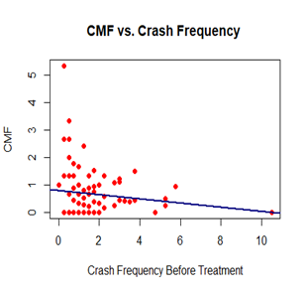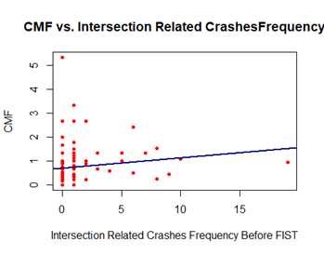

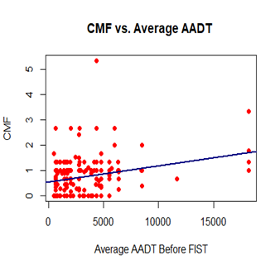

///////////////////////////////////////////////////////////////////////////////////////////////////////////////////////////////////////////

# Discussion

## Use of EB method

Through the methods explained in the methodology, the EB method helped account for the correlation between the general increase of traffic and the general increase of crashes on the monitored curves. Thus, the adjusted CMFs were lower than the original naïve Bayes method CMFs, and the EB method realized more benefit of the FISTs. As seen in tables number and number, this trend holds true for all CMFs calculated regardless of FIST or the type of crash filter, and the greatest benefits to CMFs were seen for phonolite—especially in the CMF for wet road crashes, which improved from a naïve CMF of 1.0667 to an EB CMF of 0.8616.

However, the standard deviations for the phonolite EB CMFs are greater than the difference between the EB CMFs and the naïve CMFs in all cases, indicating that the gains made through using the EB method aren’t statistically significant.

* Discuss how EB method accounts for changes in traffic volume over time and how the CMFs changed slightly because of this. Therefore rmore benefit of HFST was realized

## Crash Types

* Discuss the 5 that we moved forward with to make high quality CMFS

Because not all crashes on curves are necessarily affected by or related to the FIST implemented there—such as head-on collisions, where friction is not a cause—three distinct filters were applied to the crashes for each FIST to gain a clearer perspective of the FISTs effect on crashes where FIST does have relevance. These filters were single vehicle crashes, related crashes (where the vehicle maneuver(s) include a vehicle that is “Negotiating a curve” in the data), and wet road crashes.

## CMF model

* Discussion of the interpretation of the model. Discuss the signs of the coefficients
  + 2 factors were identified as important. Prior crash AADT and prior crash frequency roadways with high aadt and low crash frequency did not realize as much benefit form HFST.
  + The curve characteristics were not significant variables. The only change in the CMF model we could account for was prior crash frequency and traffic volume

Need help explaining actual model

After finding that prior crash frequency and average AADT were the only significant variables for the EB CMFs, curves in District 1 and District 6 were organized into four groups based on these variables. Each curve was assigned an AADT rating, which would be either low AADT (≤ 2000 vehicles per day) or high AADT (> 2000 vehicles per day), and a prior crash frequency rating, which would be either low prior crash frequency (≤ 3 crashes in the years before FIST) or high prior crash frequency (> 3 crashes in the years before FIST).

## Different materials

Out of the three materials presented in this report, HFST by far performed the best. The Empirical Bayes CMFs show that HFST reduces crashes of all types by about 33%, and even more significantly, that it reduces wet road crashes by about 55%. Phonolite was significantly less effective, with its Empirical Bayes CMFs suggesting that it reduces crashes of all types by less than 9%. These findings correlate to the friction performance of these materials over time found in that report that was done before this (ref). There were no conclusive findings for the performance of LWA, however, due to the lack of crash data.

* HFST good
* LWA TBD
* Phonolite bad but traffic volumes increased and EB realized the benefits more

## COVID-19

There were initial concerns that the decreased traffic volume during the COVID-19 pandemic would cause significant changes to the calculated CMFs. However, after comparing EB CMFs that included data from the year 2020 to EB CMFs that excluded said data, only a minimal difference was noticed, suggesting that the sample size of the data was large enough to mitigate the effect of possible traffic volume variations during the pandemic. Since crashes are rare events, it is more advantageous to utilize more years of data, and thus data from the year 2020 was utilized to increase the sample size of data after treatment to at least three years of data.

# Conclusion

Summary:

Limitations:

Future research Needs